**EXPERIMENT 04**

**AIM:** TO CREATE AN APPLICATION WHICH CREATE ALERTS UPON RECEIVING THE MESSAGE.

**OUTPUT:**

HERE THE APPLICATION RECIVES THE LATITUDE & LONGITUDE AS THE MESSAGE.

**BEFORE RECEIVING THE NOTIFICATION**

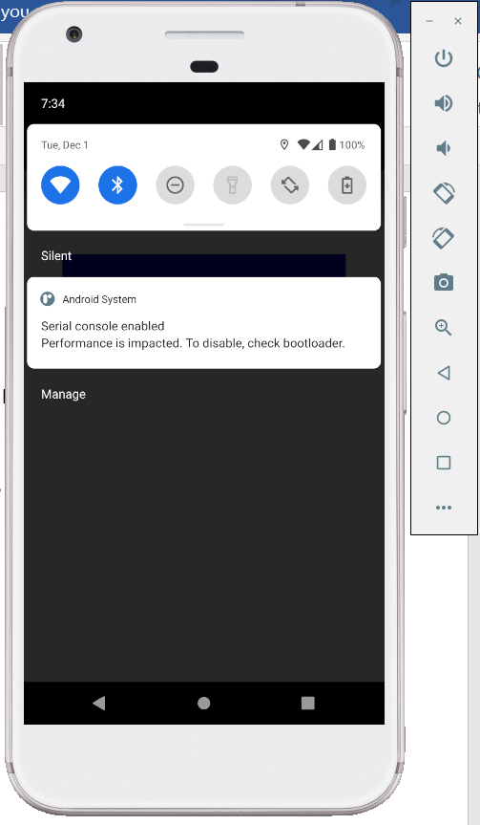

**AFTER RECEIVING THE NOTIFICATION**

